**History of banking in the US**

**The Early Days**

**1791 - The First Bank of the United States:**

Established by Alexander Hamilton, the first Treasury Secretary, to stabilize and improve the nation's credit and handle government finances.

Faced opposition from those who believed it gave too much power to the federal government.

The bank's charter was not renewed in 1811, leading to its closure.

**1816 - The Second Bank of the United States:**

Created to address the issues left by the absence of a central bank.

Operated similarly to the first bank but also faced political opposition.

Its charter was not renewed by President Andrew Jackson in 1836.

**The Era of "Free Banking" (1837-1863)**

After the closure of the Second Bank, many state-chartered banks opened with varying degrees of reliability.

This period was marked by a lack of regulation, leading to financial instability and frequent bank failures.

Banks issued their own currency, which often lost value or became worthless.

**National Banking Era (1863-1913)**

**1863 - National Banking Act:**

Established a system of national banks and a uniform national currency.

Allowed banks to receive national charters and issue government-backed currency.

Aimed to create a more stable and uniform banking system.

**Financial Panics:**

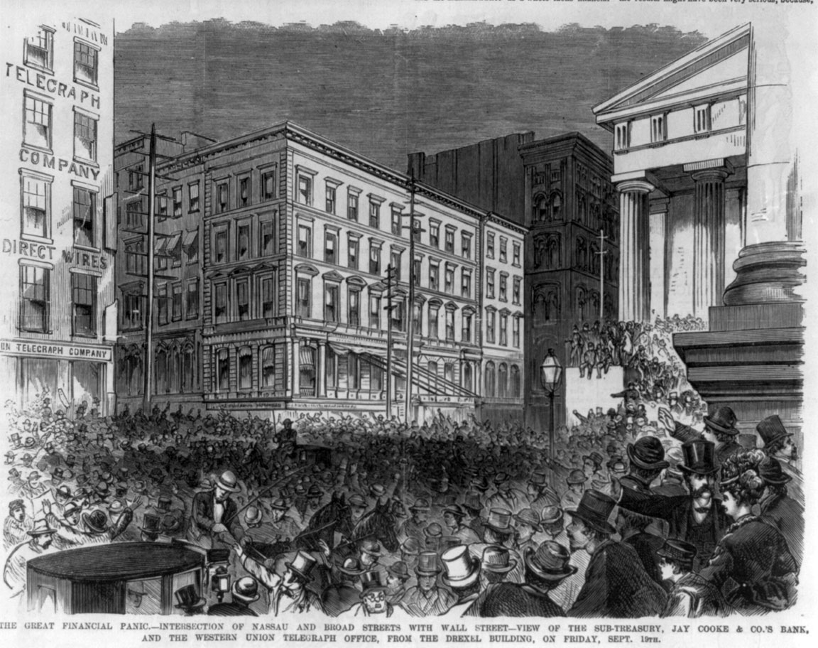

Despite improvements, the late 19th and early 20th centuries saw several financial panics (e.g., 1873, 1893, and 1907) due to economic instability and lack of a central banking system.

Economic instability in 1873, 1893, and 1907 was largely due to overexpansion and risky investments, particularly in railroads and speculative ventures, combined with agricultural issues and the absence of a central bank. The failure of significant financial institutions like Jay Cooke & Company, Philadelphia and Reading Railroad, National Cordage Company, and Knickerbocker Trust Company led to widespread panic and numerous bank failures during these periods.

**The Federal Reserve System (1913-Present)**

1913 - Federal Reserve Act:

Created the Federal Reserve System (the Fed) to serve as the central bank of the United States.

Designed to provide a safer, more flexible, and more stable monetary and financial system.

The Fed manages the nation's money supply and serves as a lender of last resort to banks.

**The Great Depression and New Deal Reforms:**

**1933 - Glass-Steagall Act:**

Established the Federal Deposit Insurance Corporation (FDIC) to insure bank deposits and restore public confidence in the banking system.

Introduced banking reforms, including the separation of commercial and investment banking to reduce risk.

**Post-WWII Banking:**

The banking industry grew and evolved with the economy, expanding services and adopting new technologies.

Regulations and oversight increased to ensure financial stability and consumer protection.

**Late 20th Century Deregulation:**

**1980s and 1990s:**

Period of deregulation, allowing banks to offer a wider range of services.

The Glass-Steagall Act was partially repealed in 1999, allowing commercial and investment banks to merge.

**The 21st Century and Financial Crisis**

**2007-2008 Financial Crisis:**

Triggered by the collapse of the housing market and risky banking practices.

Led to the failure of major financial institutions and a global economic downturn.

Prompted significant government intervention and the passage of the Dodd-Frank Wall Street Reform and Consumer Protection Act in 2010 to increase regulation and oversight.

**Modern Banking**

The rise of digital banking, online services, and mobile apps has transformed how people manage their finances.

Fintech companies and innovations like cryptocurrencies are reshaping the banking landscape.

Ongoing regulatory adjustments aim to balance innovation with financial stability and consumer protection.



The history of banking in the United States is a story of growth, innovation, and adaptation, driven by the need to manage the nation's finances, provide economic stability, and respond to crises.

**Summary of US banking History**

The United States, people needed a safe place to keep their money. In 1791, the first bank, the Bank of the United States, was created but closed after 20 years. After that, many small banks popped up, but they were often unreliable. In 1913, the Federal Reserve was established to bring stability and manage the country's money.

During the Great Depression in the 1930s, many banks failed, so the FDIC was created to insure people's deposits, protecting their savings. Over the years, more rules were made to keep banks safe and fair. In the late 20th century, banks expanded their services and technology brought online and mobile banking.

Today, multiple agencies like the Fed, FDIC, and CFPB work together to regulate banks, ensuring they operate safely and fairly, keeping people's money secure and maintaining confidence in the banking system.

**How they regulate banking system**

The Federal Reserve (The Fed):

Manages the country’s money and interest rates.

Supervises and regulates banks to ensure they are safe and sound.

The Office of the Comptroller of the Currency (OCC):

Oversees national banks to make sure they follow laws and operate safely.

The Federal Deposit Insurance Corporation (FDIC):

Insures people's deposits (up to $250,000 per person, per bank) so they don’t lose money if a bank fails.

Examines banks to ensure they are healthy and manages failed banks.

Consumer Financial Protection Bureau (CFPB):

Protects consumers by making sure banks treat them fairly.

Enforces rules about loans, credit cards, and other financial products.

State Regulators:

Supervise state-chartered banks to ensure they follow local laws and operate properly.